

Firefly – T HE P C G A M E

Including…

Blue Sun Rim Expansion*

Kalidasa Rim Expansion

OVERVIEW

So, you want to play **Firefly the Game** but maybe you don’t want the hassle of setting up all the game’s components and shuffling the many decks. Maybe you want to try out new strategies by yourself before wowing your regular boardgame group. Or perhaps it’s a slow day at work and you need to blow off some steam and play at picking and delivering contraband through the Verse.

*Welcome to Firefly the PC Game.*

Before you sit at the captain’s chair, you might want to browse this manual to properly learn how to command full control over your Ship, Crew and Gear.

This manual assumes you are already familiarized with the (included) rules for the core game, Blue Sun and Kalidasa expansions, those will remain largely the same. But do keep in mind that a few liberties had to be taken to improve the digital experience.

WINDOWED DISPLAYS

Just like your tabletop game is divided into several areas and boards, this version of the game distributes the information into distinct windowed displays. The windows can be docked or independently arranged so you can best customize your preferred layout for your screen.

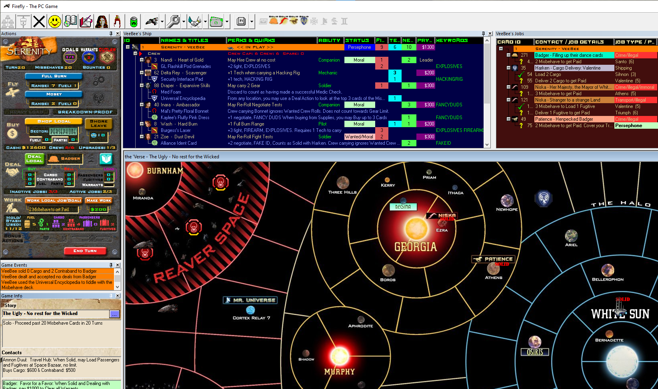  
*(Layout example)*

THE TOOLBAR

This will be your main control panel. Clicking the buttons and their options (via the dropdown menu) will open new displays you might want to familiarize yourself with. Details are further explained in the **Running a Game** section.



 **Host:** Create and host a new game.

 **Join:** Connect to someone else’s game.

 **End Game:** Gives you the option to **withdraw** from a game.

 **Chat**: Communicate with the other players.

 **Game Info:** Shows the story goal and the benefits of being solid with each contact.

 **Game Log:** Keeps track of the game’s actions.

 **Crew/Gear/Ship Upgrades Browser:** Shows all available cards and their stats.

** Ship Browser:** Displays ships’ contents: Crew, Gear, Cargo, and Ship Upgrades. It has a dropdown menu option to display All Ships, or just your Ship.

 **Job Browser:** Shows your active and inactive jobs. It has a dropdown menu option to display jobs for All Players, or just your own Jobs. Note: other players jobs only can be seen if they are active.

 **Deal Browser:** Shows all available jobs, divided by Contact. It has a dropdown menu option to display All Deals, or just Deals from the local Contact.

 **Buy Browser:** Shows all crew/gear/ship upgrades available for purchase, divided by Supply Planets. It has a dropdown menu option to display All Buys, or just Buys from the local Supplier.

 **Game Rules:** Opens this document and the rules for the game and its expansions. Other options are for Job Editing, starting an AI Bot (used when restarting a game), checking the latest game release version, and the About display that shows your current version number.

GAME SETUP

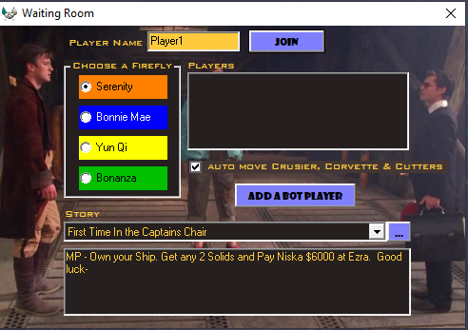Press the Host button on the toolbar to get started.  
Check the **Multiplayer Mode** section for details on playing with more opponents.

Put down your name and choose a Firefly color. Then, click the “Add a Bot Player” button once per Bot if you want to add AI opponents to the game.

Auto move is recommended. If checked, NPC Ships (Cruiser, Corvette & Cutters) will move via AI. Otherwise, human players will manually have to move the ships.

Pick an existing Story or add a custom one of your making by choosing “Add New” at the end of the dropdown list.  
*See the “****Advanced – Customizing Stories****” sidebar further below for details*.

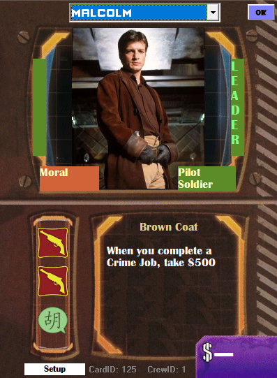Press the Join button to lock the players, then click Start to roll the ‘dice’ which selects who will get first dibs on a Leader and starting location.

When you are prompted, scroll through the Dropdown list to pick an available Leader that better suits you.

Some Stories will allow you to pick additional Crew from the get-go. There will be a limit on the number of crew you can select and their overall Hire Cost. Once you start selecting crew, notice that the Hire Cost and Skill Points total are displayed at the top of the Pay/Job column.

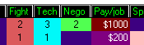

GAME SETUP (cont.)

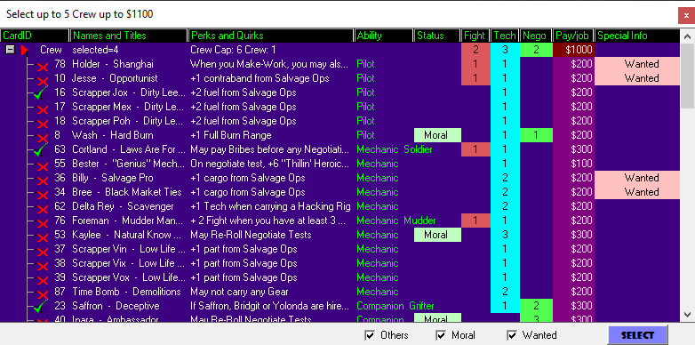

Filters are available on this page to allow you to target a few key groups. Don’t want the Wanted? Remove the tick. 

Press Select once to continue. In reverse order of players (for Multiplayer) you will be asked to select a Sector on the map.

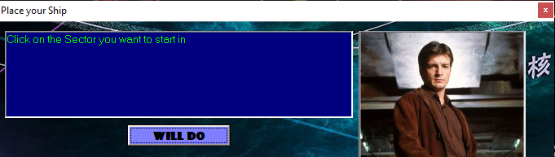

Click Will Do, and then click on a Sector on the Map. You can use the Scroll bar at the side and bottom of screen to bring unseen portions of the Map into view.

It is possible to Click and Drag the Map directly to pan it around, but be careful of mis-clicking during a Sector selection.

Now you are ready to start playing.

ADVANCED – CUSTOMIZING STORIES

Viewing and editing Stories is always possible by pressing the ellipsis button during Game startup: 

You can peruse the Goals details and, if you are making a new story, add startup parameters and new Goals. If you are adding special “goal” Jobs to a story, they should be setup beforehand (See Job Editing).

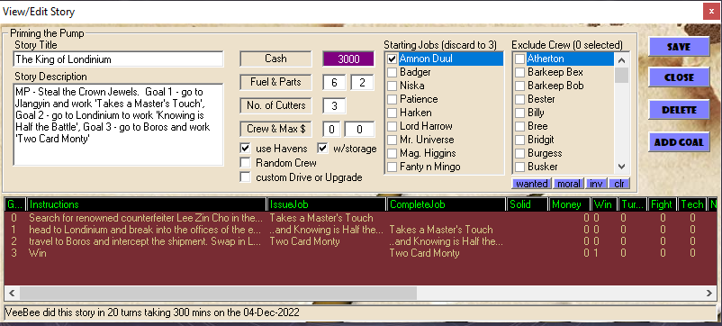

Remember that **stories should always have a Goal ‘0’**, as it provides a place for **startup instructions** and *optionally* an initial goal Job. Double-Click a Goal in the List if you want to view or edit it.

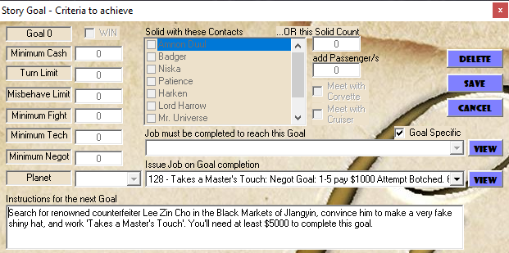

“Goal Specific” Jobs *(ContactID=0)* are Jobs that are not available from any in-game Contact. However, it is possible to choose from Contact Jobs for goals by deselecting the ‘Goal Specific’ flag.

The last Goal should have the Win Flag set to ensure that a logical end game condition occurs.



Press Save after Story editing is done to save any changes.

RUNNING A GAME

**Turn Actions Panel**

Your best friend. Here is where you will select all **Actions** available on your turn.

Only Actions available in your current location will be available to you. *Eg. If you are at a Contact’s location, the Deal action will be available.* When appropriate, other functions may appear on the Action Display from time to time based on Gear or Crew abilities. *(eg. Resolve Alerts, Morale Boost)*

Mosey **and** Full Burn**:** Click on an adjacent Sector to fly to it.

*Some sectors have a smaller ‘hotspot’ for registering mouse clicks, so it’s always best to click in the center of the sector.*

To keep flying when Full Burning, resolve the Nav Card, click Full Burn again, and select a new sector. Repeat until you want to stop Flying or you run out of Range. Doing another Action will disable your Full Burn Action for the rest of the turn.

Buy **and** Deal Local**:** You get to choose what you want in the **Buy** or **Deal Display**.

When able, you may buy or sell Cargo & Contraband as part of a Deal Action or buy Fuel and Parts as part of a Buy Action. To do so, enter the number of goods you want to buy or sell in the appropriate boxes in the Actions Display. Changes to your cash and goods will be reflected when your Action is complete.

*The ‘Shore Leave’ option, as per the Rules, takes up a Buy action.*

Work Local Job/Goal**: A**ny Job that is workable will appear in the work dropdown list. Pick any one to Work for that action. All Planet Sectors have the ‘Make Work’ Job available. If you have multiple jobs available for a planet, make sure to check the ID number to verify the Job you will work.

End Turn: You may end the current turn even before all available actions have been used.

Top left is the turn counter, used in some gameplays as a target to finish before a certain number of turns run out.

In Solo Mode you can do any number of available Actions once, but you must manually end your turn to prompt the next round. In Multiplayer your turn will automatically end in most cases, usually after 2 Actions have been completed.

**SHIP DISPLAY**

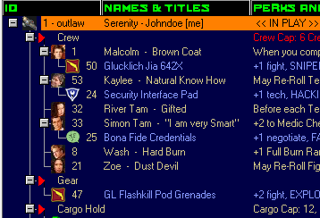The home for your Crew, Gear, Cargo, and Ship Upgrades.

Remember that only Gear linked to a Crew member is counted on a Job, so be sure to allocate any unlinked Gear to a Crew. drag and drop Gear onto a Crew member. The drag icon will appear. 

To remove gear, drag and drop the Gear back onto the Gear Heading.

You can also View or Discard Crew members or Gear via the Right-Click Menu. Other menu functions may become available as well with certain gear and goods.

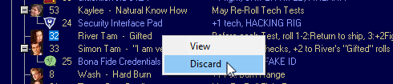

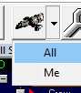**Trading and Poaching Crew:** If you are in the Same Sector as another Player’s Ship, you might want to Trade Supplies. To do so, make sure you select the ALL in Ship Display, so you can see your opponents’ ships. Right-click on their Name to open the trade dialog. Right-Click on a disgruntled Crew member to make ‘a Better Offer’, subject to paying their hire fee.

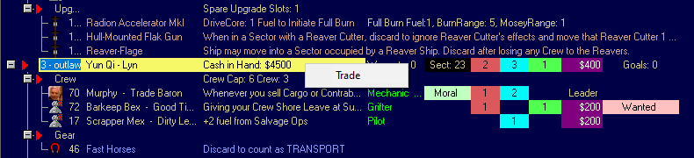

**JOBS DISPLAY**

This is where you can manage your Active and Inactive Jobs. As you progress through Jobs, their stages get marked with a Tick to show completion.

Inactive Jobs may be discarded by right-clicking on them.

**DEALS DISPLAY**

At a Contact’s location, you may use a Deal Action to access a list of Jobs. Sometimes, at the start of a game, the list (*i.e., the discard pile*) will be empty.

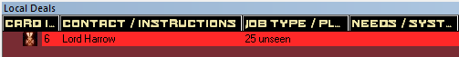

The button caption will change to Draw Cards; press it to reveal 3 new Jobs from the deck.

Deals up for Consideration are marked with a **“?”**. As you select Jobs, they get ticked. When you are ready, click Close Deal and the selected Jobs will be added to your Jobs Display.

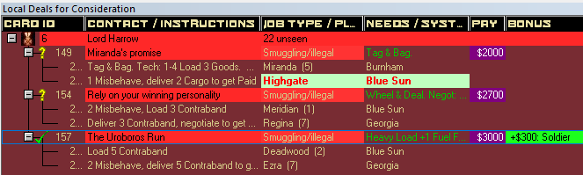

If you have already taken the maximum inactive Jobs (usually 3) you won’t be able to select further new jobs and an error sound will play to let you know.

If you purchased or sold Cargo or Contraband with the Solid Contact the cash amount will be updated when you Close the Deal.

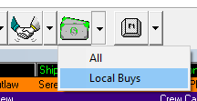**BUY DISPLAY**

The Buy Display works very similarly to the Deals display.

In the Buy Display Toolbar dropdown menu (as in most menus) you can chose between seeing **All** available cards for purchase across all Supply planets discards, or just show the **Local Buys** if you are located at a Supply point.

When you use a BUY action, each item will start marked with an “**X**”. You may select up to 3 items to tag them as ‘Considered’, which will mark them with a “**?”**, or select none if you want to consider 3 fresh items.

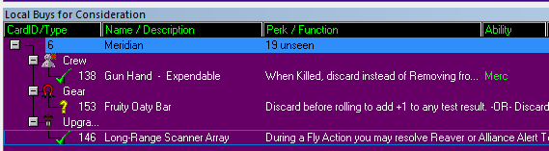

When you are ready, click Draw Cards to reveal any extra cards if appropriate.

Tick the items you want to buy and choose Finish Buy to complete the transaction.

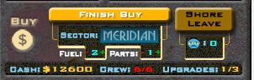

*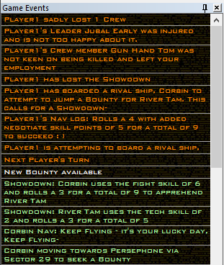 Don’t forget to add any Fuel or Parts before you Close the Buy action!*

**GAME LOG**

Keeps everyone up with what’s happening with the most recent event always at the top. Maybe toggled on/off with the toolbar button. Entries are color-coded to the player.

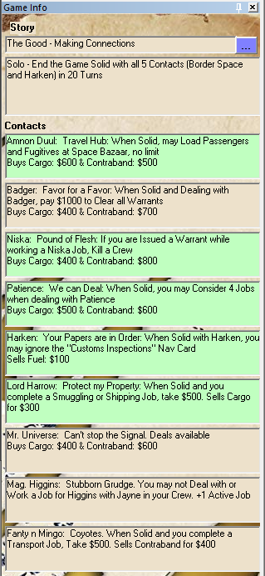

**GAME INFO**

It provides a reminder of the Story objectives. It also shows the benefits for Solid Contacts and who you are Solid with in a green background.

*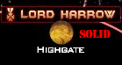Solid status is displayed on the toolbar for quick reference.*

*Solids are also displayed directly on the Map, next to a Contact.*

MULTIPLAYER MODE (MP)

Up to **four** players are supported, however all players must have file access to the same Game Database (*FireflyKalidasa.mdb*). To do so use a File Server on a LAN, or share a local folder on the host PC, and then install the Game to this Shared Folder.

All Users should start *FireFlyKalidasa.exe* from this shared folder, after installing the game on their own PC, in order to register the supporting files.

Playing over the internet is possible if a good VPN connection is configured to grant the same access mentioned. But results may vary depending on the quality of the VPN Client/Server. The generic Windows built-in VPN is poor in my experience.

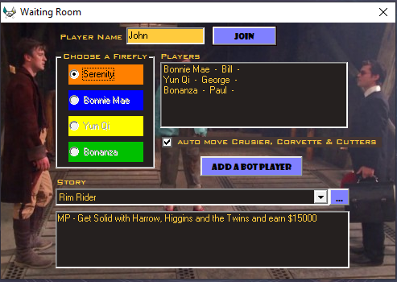**SETUP**

The Host sets up the waiting room with the button and the other players use the  button to get a similar screen.

Once all players have selected a ship and Join ed, the Host must click START to begin.

A random roll lets one person at a time select a Leader, and then in reverse order selects a starting Sector. When the Turn Actions display appears for each player it means their turn has begun.

In multiplayer it’s possible for all to exit the game, and later resume the game where you left off. Simply have all players close the application at the start of any player’s turn, before any actions have been performed.

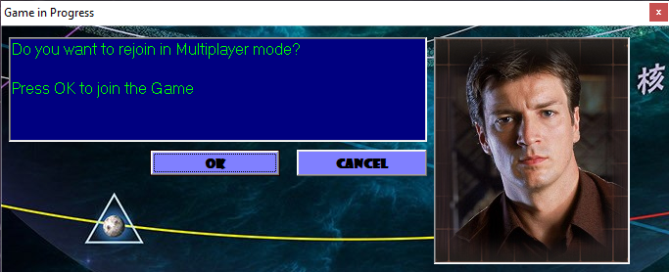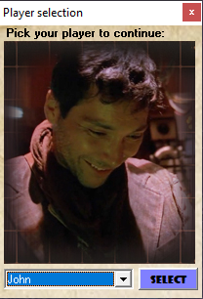When you are ready to resume the game, the game will auto-prompt you to confirm a re-join. Select your name from the player selection. If it was your turn when the game was closed, Actions will be immediately available.

**Note:** It’s entirely possible that each player could start, rejoin, play their turn on their own, then exit after the turn has passed to the next player. *i.e. The Game does not need a “Host” once it has commenced.*

Use the ‘End Game’ toolbar button  if **you** wish to **withdraw** from a game altogether. If it was your turn, the turn will be passed to the next player.

**Playing Against AI**

There are 2 “Robot” themed Stories to try out.

To play against one or more AI Bots, click the ADD A BOT PLAYER in the Waiting Room you begin after clicking to Hosting a game. The AI will connect to a free ship and take the name of that ship as their player name.

Bots can compete for a specific Solid Contact, reach a number of Solids Contacts, Cash held, and a Turn limit. But other Goal types are ignored and will never be reached. AI Bots can only achieve Solid with *Amnon Duul, Badger, Patience, Harken, Harrow, Higgins and Mr. Universe*, because they can only do Legal, amoral Jobs.

SAVING A GAME

Every action is saved real-time in the Game’s database so you can preserve a game in progress. But there is a way to save multiple game sessions more permanently, in case you want to start a fresh game then resume a previously saved game.

After quitting a game in progress (just by closing the window, **NOT** by clicking the End Game ‘X’ button in the toolbar *which would remove you from the current game*), go into the game’s folder and copy/paste the “FireflyKalidasa.mdb” data file, and rename the new copy.

*Eg. FireflyKalidasa_GameNightSave.mdb*

Then restart a new Game using the Host button as usual – choosing to ‘reset’ the game in progress. And when you are ready to resume your ‘GameNightSave’, delete or rename the current data file, then rename the save file back to ‘FireflyKalidasa.mdb’ and start up the game again.

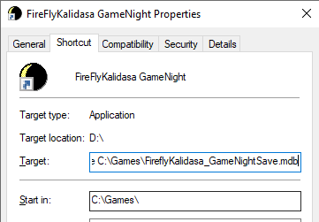

Alternatively, you can setup a new game Application shortcut for each ‘save’ file, placing the full path to the data file after the FireFlyKalidasa.exe in the Target.

This way you could have many in-progress games available to start.

**NOTE:** For Multiplayer, all users must have access to start this shortcut, which needs to exist in a shared LAN Folder.

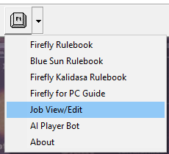

ADVANCED – JOB EDITING



It is possible to add or edit Jobs if you are inclined to do so. Under the  
 Help dropdown menu, there is an option for Job view/edit.

Using the editor, it would be possible to setup your own custom Jobs  
for Mr. Universe for example, on account that the game’s original “Big  
Damn Challenges” are not supported in this version.

**NOTE:** New Contact or Goal jobs can be added this way. It is  
recommended you peruse and study existing Jobs to see common  
attribute combinations, as choosing unproven combos may have  
unpredictable results. There is no cross validation in place to prevent  
invalid or conflicting selections.

DEVELOPER NOTES

* Mr Universe’s “Big Damn Challenges” are not supported from the original game. However, many “standard” format jobs have been added to this contact in their place.
* Motherlode and Uroboros Belts are not supported exactly as mentioned in the Rules. Jobs originally for them are allocated to one of the planets in the belt.
* The game uses several custom fonts in various places. They are included in the Setup if your PC does not already have them.
* Special thanks to **phideaux1, myst17** & **gwek** for their assistance in getting this project this far.

***Keep flying!***

***VeeBee-er***

